<https://www.news18.com/news/india/justice-still-eludes-44-dalits-in-tamil-nadu-who-were-charred-to-death-50-years-ago-on-this-day-1983011.html>

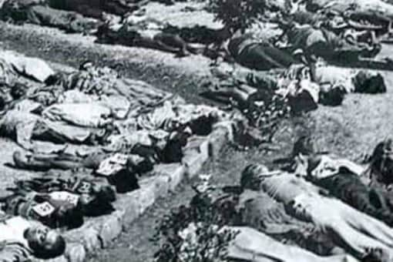

Twenty women, 16 children and 5 aged men were burnt alive in Kilvenmani on the night of December 25, 1968.

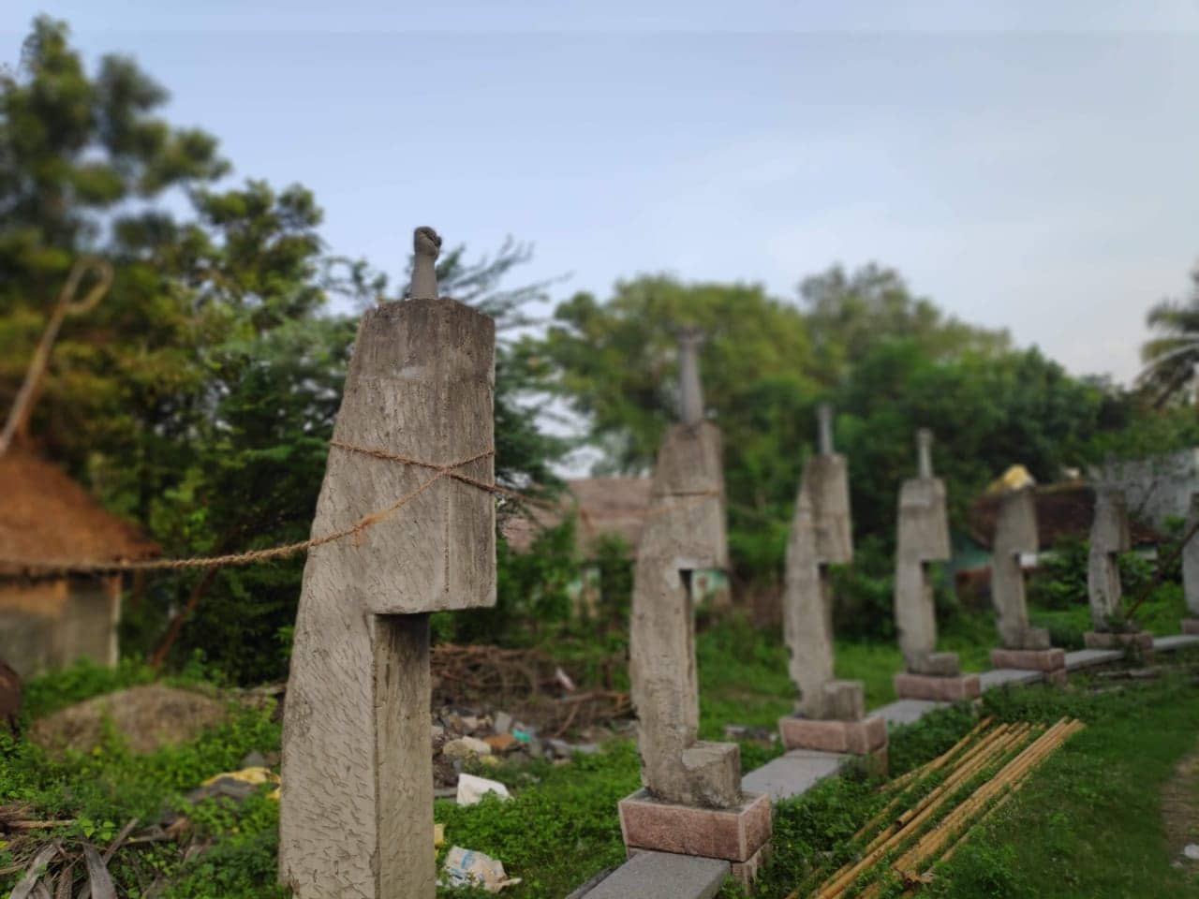

*CPM workers have now constructed cemented hands at the spot where the massacre had occurred.*

[**https://www.newindianexpress.com/states/tamil-nadu/2018/dec/25/things-changed-but-a-lot-more-yet-to-be-done-say-experts-1916077.html**](https://www.newindianexpress.com/states/tamil-nadu/2018/dec/25/things-changed-but-a-lot-more-yet-to-be-done-say-experts-1916077.html)

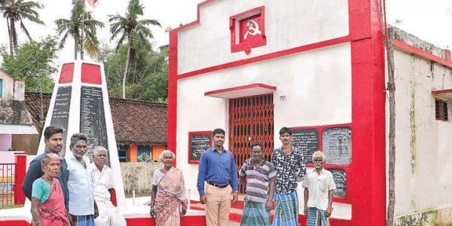

Survivors of Keezhvenmani Massacre and the younger generation at the Old ‘Ramaiyan Hut’ Memorial where 44 villagers were burnt to death. | (Antony Fernando | EPS)

<https://www.thehindu.com/news/national/tamil-nadu/keezhvenmani-the-first-chronicle-of-violence-against-dalits-in-independent-india/article25826814.ece>

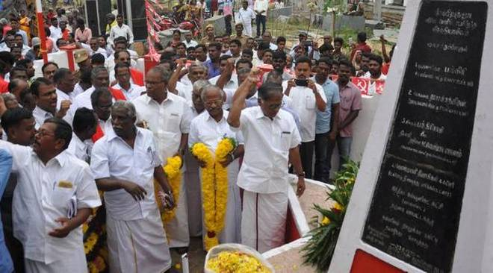

Tamil Nadu CPI (M) leaders pay homage at the Keezhvenmani massacre memorial at Keezhvenmani village in Nagapattinam district, Tamil Nadu on December 25, 2017. Photo: Special Arrangement

<https://thewire.in/caste/keezhvenmani-massacre>

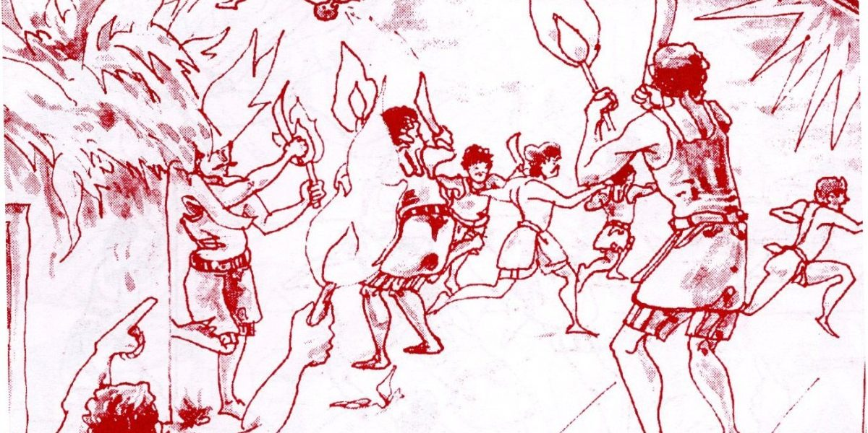

Credit: S. Tamilselvan

<https://feminisminindia.com/2019/12/27/what-do-we-know-today-about-the-keezhvenmani-massacre/>

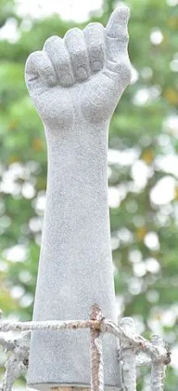

*Image source:  
Raised fist carried as part of the 2014 inauguration of the Keezhvenmani martyrs memorial, Wikipedia*

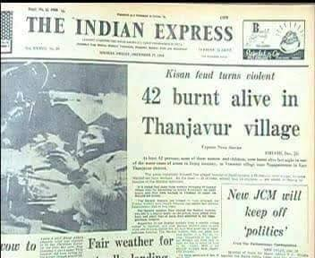

Image Source: News18.com

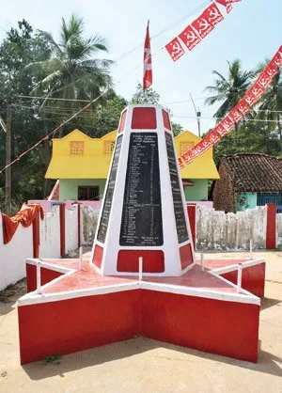

*Image source: Keezhvenmani Memorial*

<https://ruralindiaonline.org/en/articles/keezhvenmani-huts-ground-to-dust-and-ash/>

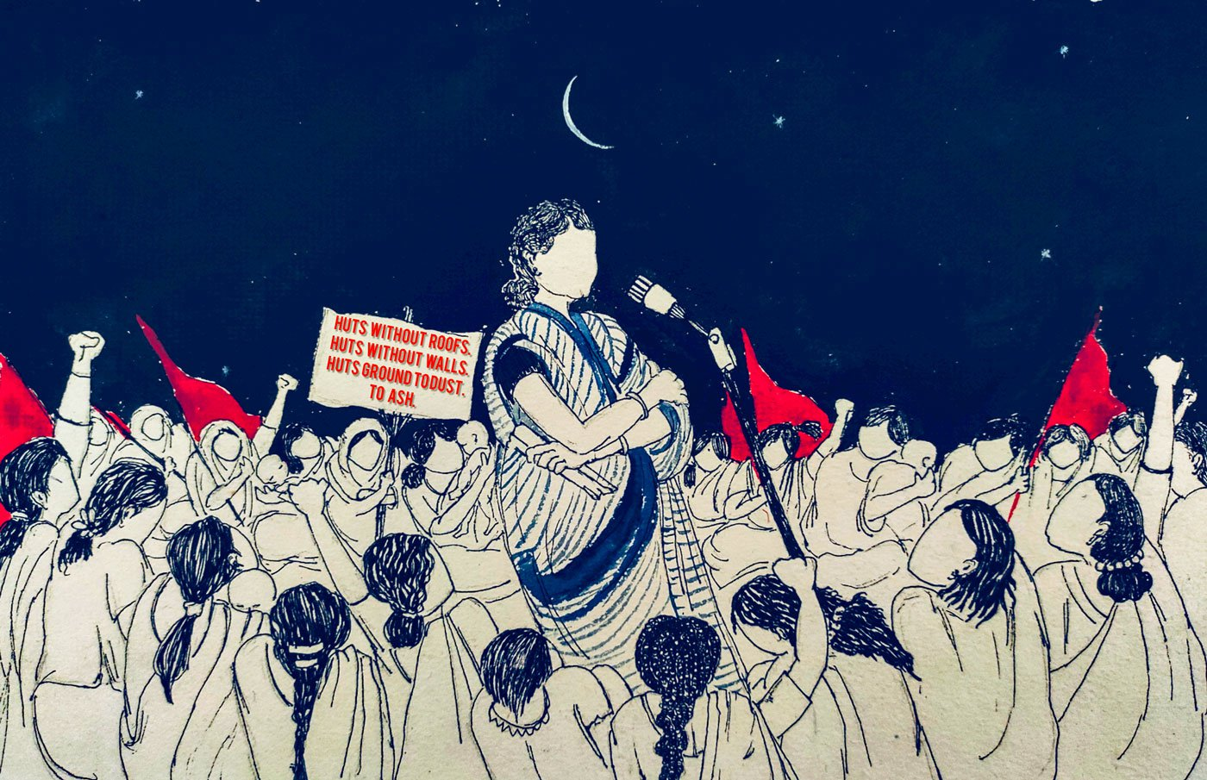

* Poem and Text : [Sayani Rakshit](https://ruralindiaonline.org/en/authors/sayani-rakshit/)
* Painting : [Labani Jangi](https://ruralindiaonline.org/en/authors/labani-jangi/)

<https://www.newindianexpress.com/states/tamil-nadu/2017/dec/24/fire-of-1968-still-burning-inside-1735689.html>

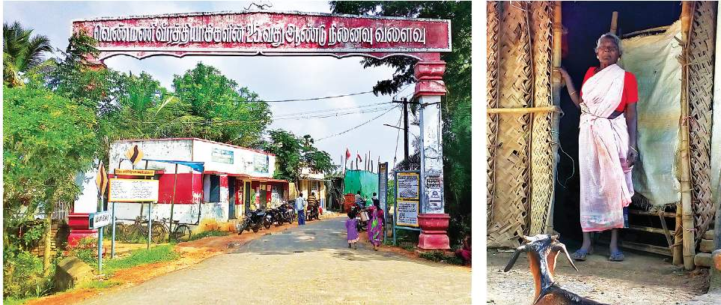

An arch built to mark the 25th anniversary of the massacre welcomes visitors to Keezhvenmani; R Maniyammal, who lost her sister and the latter’s 8 children | M MANIKANDAN

<https://www.thehindu.com/news/national/tamil-nadu/New-memorial-to-commemorate-Keezhvenmani-massacre/article11405049.ece>

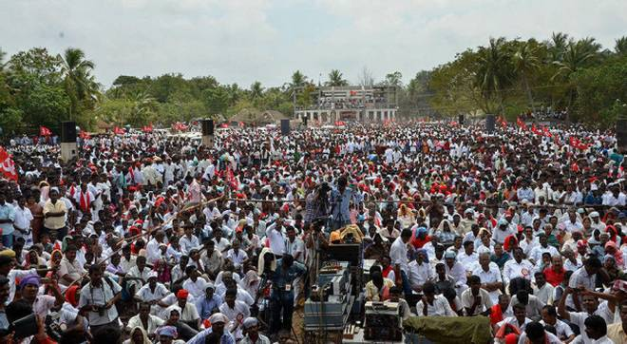

CPI(M) cadre at the commemoration of the memorial at Keezhvenmani on Sunday. Photo: B.Velankanni Raj

<https://en.wikipedia.org/wiki/Kilvenmani_massacre#/media/File:Vens.jpg>

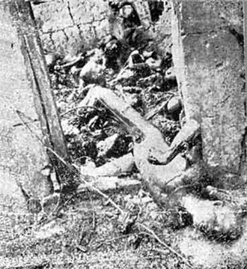

44 people burnt alive

<https://feminisminindia.com/2019/12/27/what-do-we-know-today-about-the-keezhvenmani-massacre/> check the image here in fii – more female representation in the cartoon